Assignment-Hooks

* Launch a EC2 instance.
* Install java : yum install java-11-amazon-corretto.x86_64 -y
* Create a directory called “Servers” in /mnt and install Tomcat in same
* Go to Servers directory 🡺 wget <tomcat zip link> 🡺 unzip 🡺 Give full permission to file 🡺 Go to Webapps 🡺 (Install Jenkins) wget <Jenkins WAR file > 🡺 Start the tomcat from bin : ./startup.sh 🡺 For accessing the tomcat goto browser : <public ip>:8080/Jenkins
* Provide initial admin password, install suggested plugin and give username details to see Jenkins UI
* Meanwhile install git. (Can be done from Jenkins too)

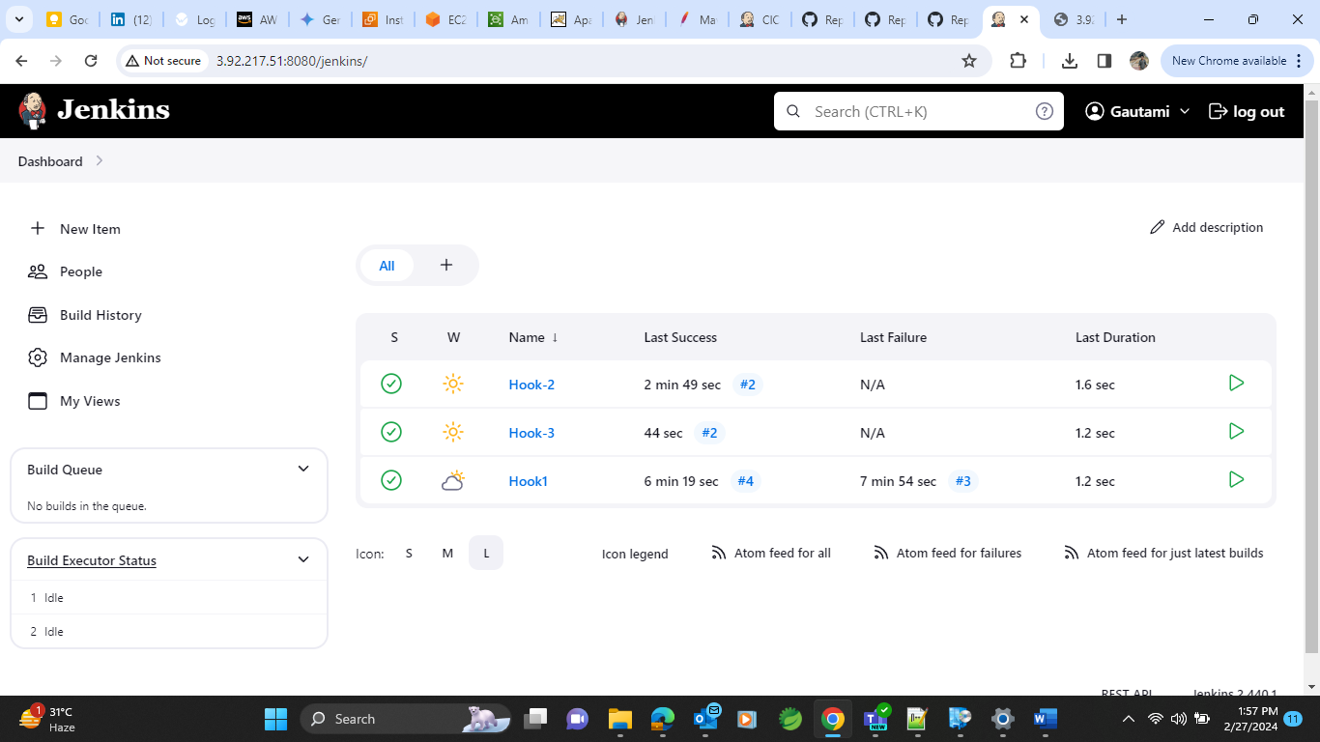

* Create a jobs named hook-1, hook-2, hook-3 respectively for 3 repos. As shown below-

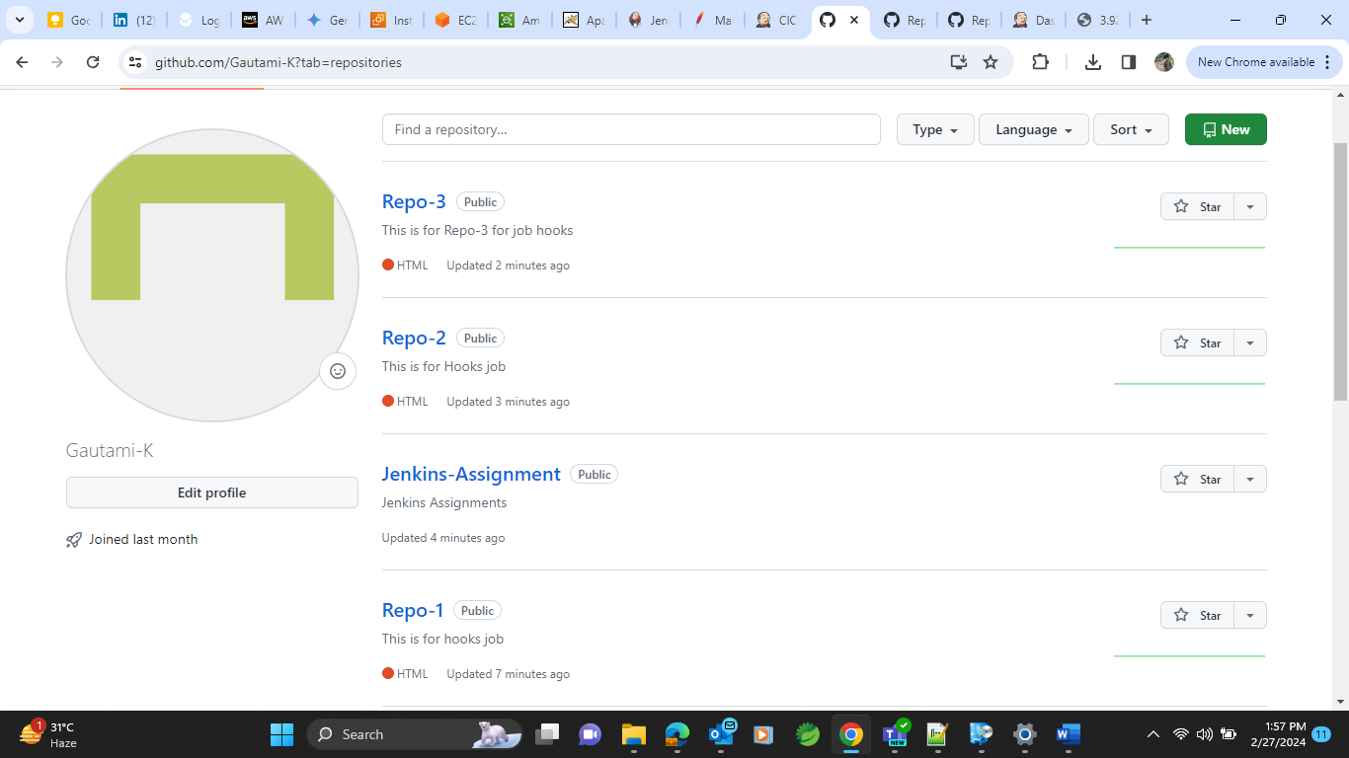

And git config like :

Repo setting 🡺webhook🡺Add webhook and give password 🡺 give Jenkins url with /github-webhook ,content-json 🡺choose just the push event🡺 and setting is done .(see the right sign to check if its done)

Do same process for all the repos for all the respective jobs.

* Do the Github server setting in Jenkins for all the three repos as shown below:

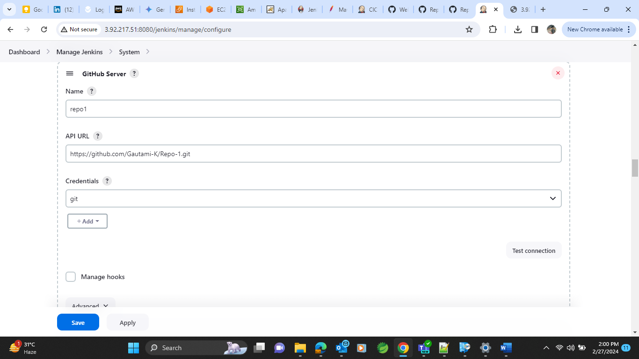

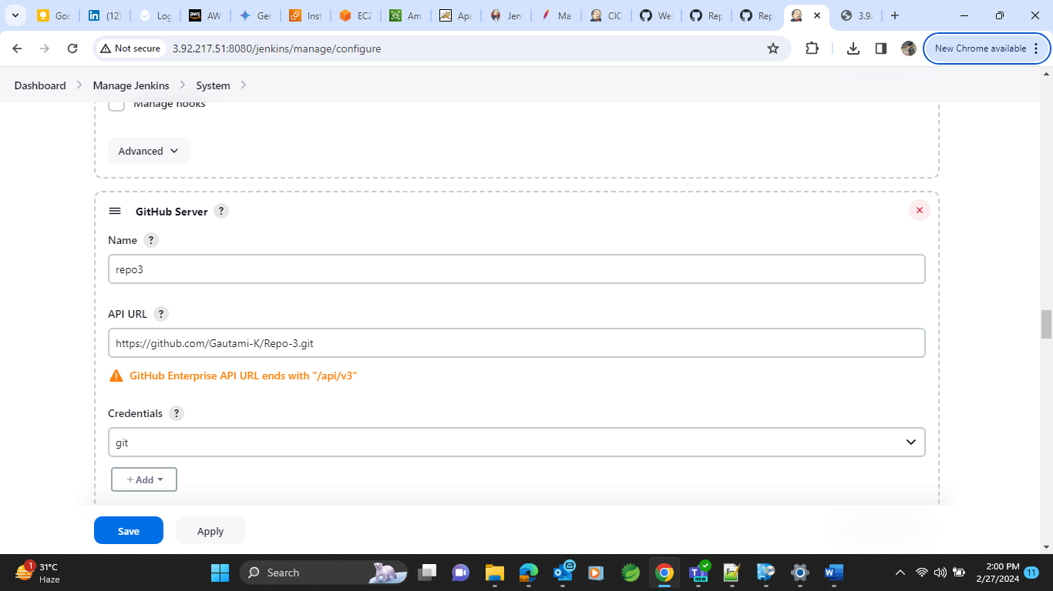

* For each job Do settings like:

Inbuild trigger 🡺Github hook trigger with git scm 🡺 Apply and save

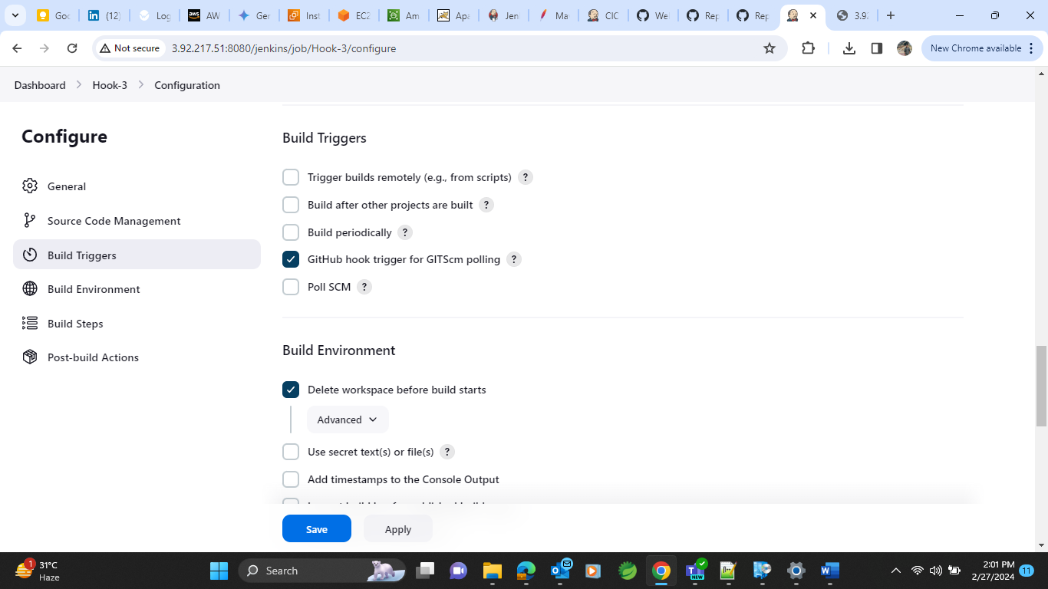

Now while accessing any change in git repos index.html file will result in invoking the same repo and with the help of httpd server we will be able to see that on browser.

For job 1 when we do build, new build is generated.

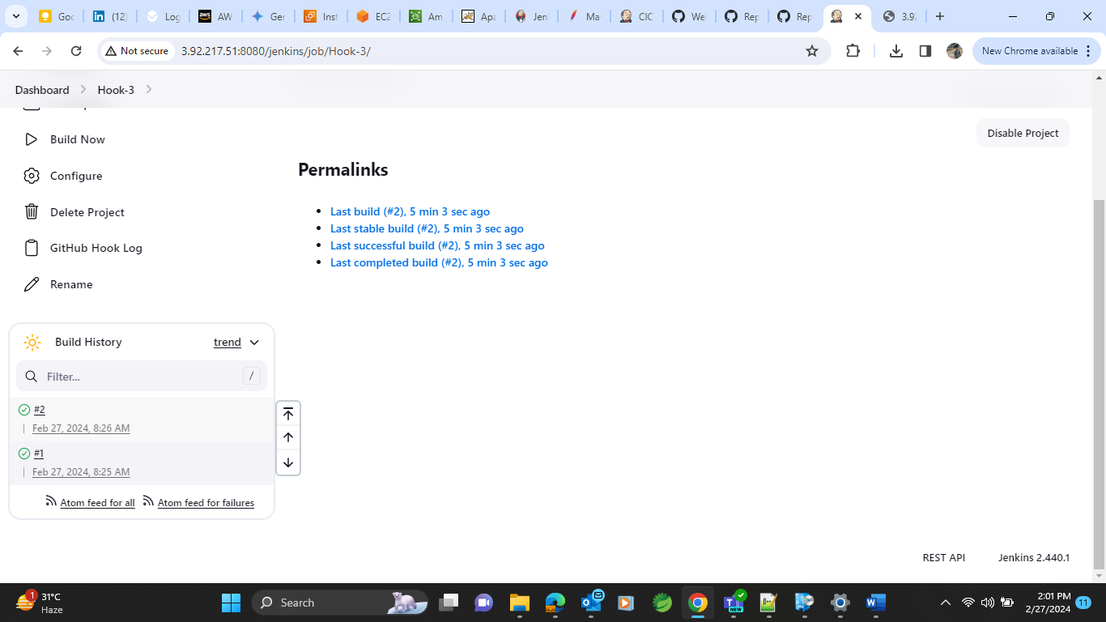

And we can see that on browser like :

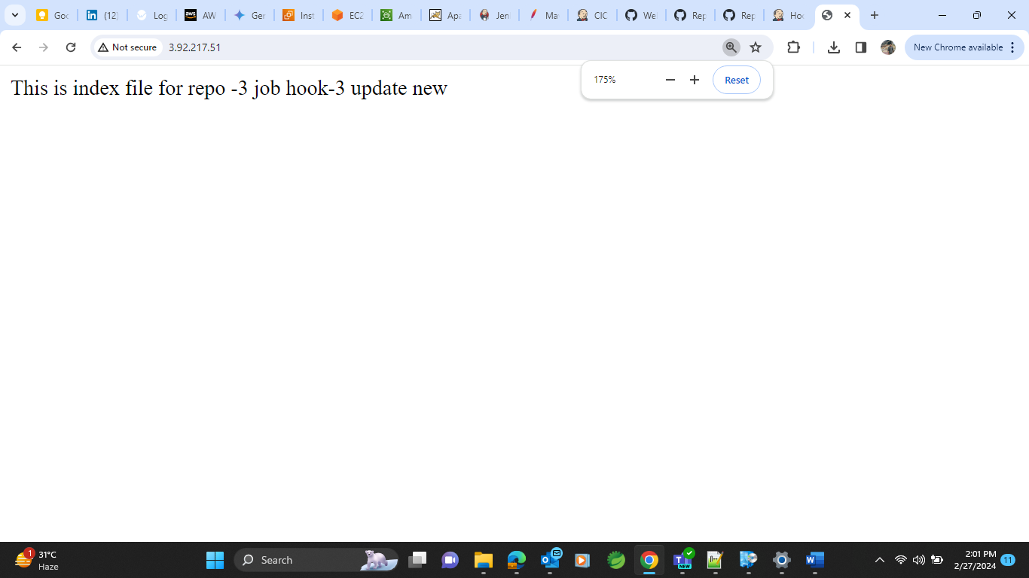

And same will happen whenever we update git repo of particular job we will get index.html invoked for each job build